21.71: a)
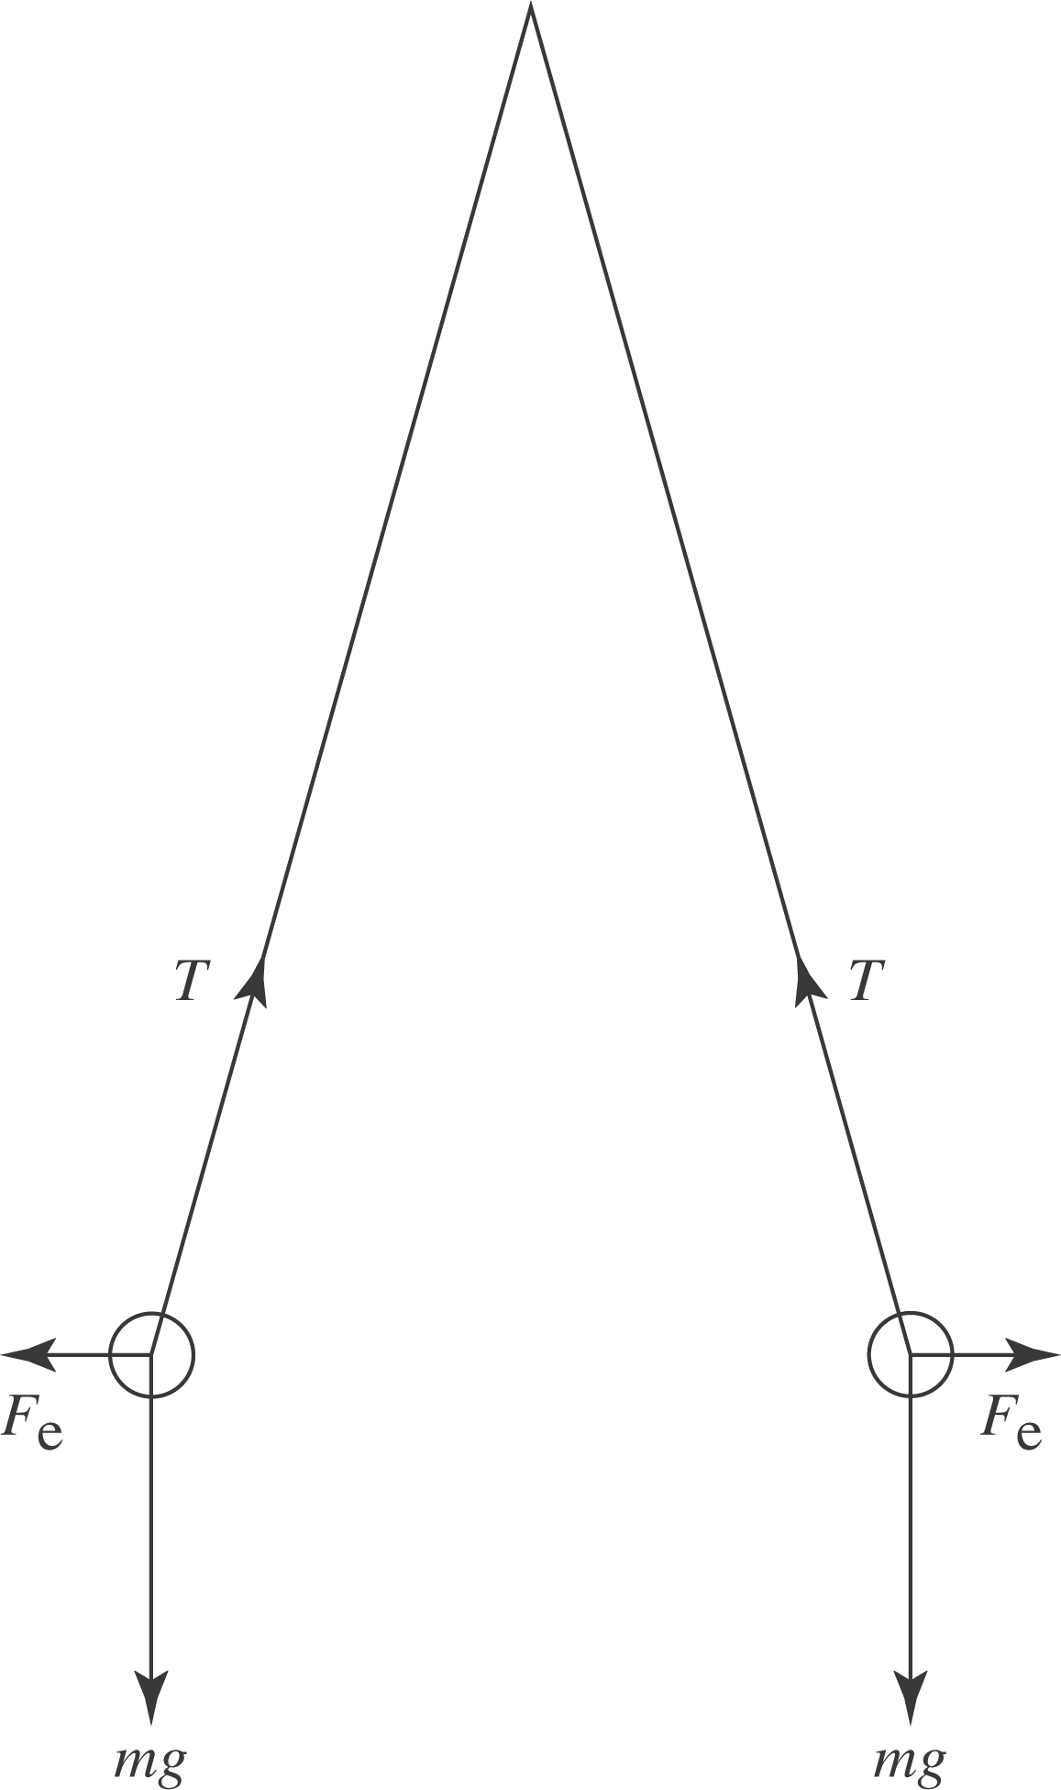
b) Using the same force analysis as in problem 21.70, we find: 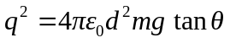and
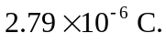
c) From Problem 21.70, 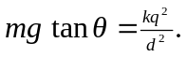
Therefore 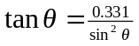. Numerical solution of this transcendental equation leads to 